CAREER OPPORTUNITY
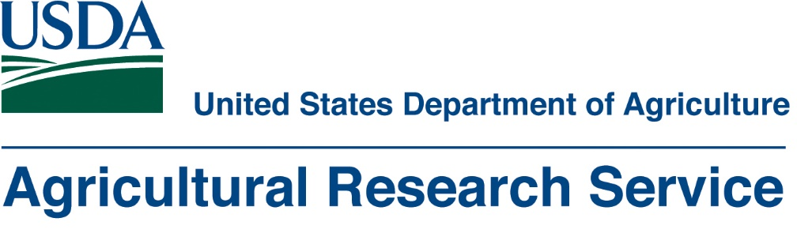
USDA-ARS Invasive Species and Pollinator Health Research Unit
Albany, California (San Francisco Bay Area)
is seeking an
Entomologist
Support Scientist (Category 3)
This position will support a Research Entomologist conducting research on biological control of invasive terrestrial and aquatic weeds using insects as biocontrol agents.
This is a permanent, full-time career position
Salary: GS9 or 11 ($61-$96K)
Full vacancy announcement and application instructions: https://www.usajobs.gov/GetJob/ViewDetails/516398400
Open to U.S. citizens or U.S. nationals
Deadline to apply: Tuesday 11/27/2018
Agency Contact for More Information: Hanna Lugo, hlugo@yrci.com

