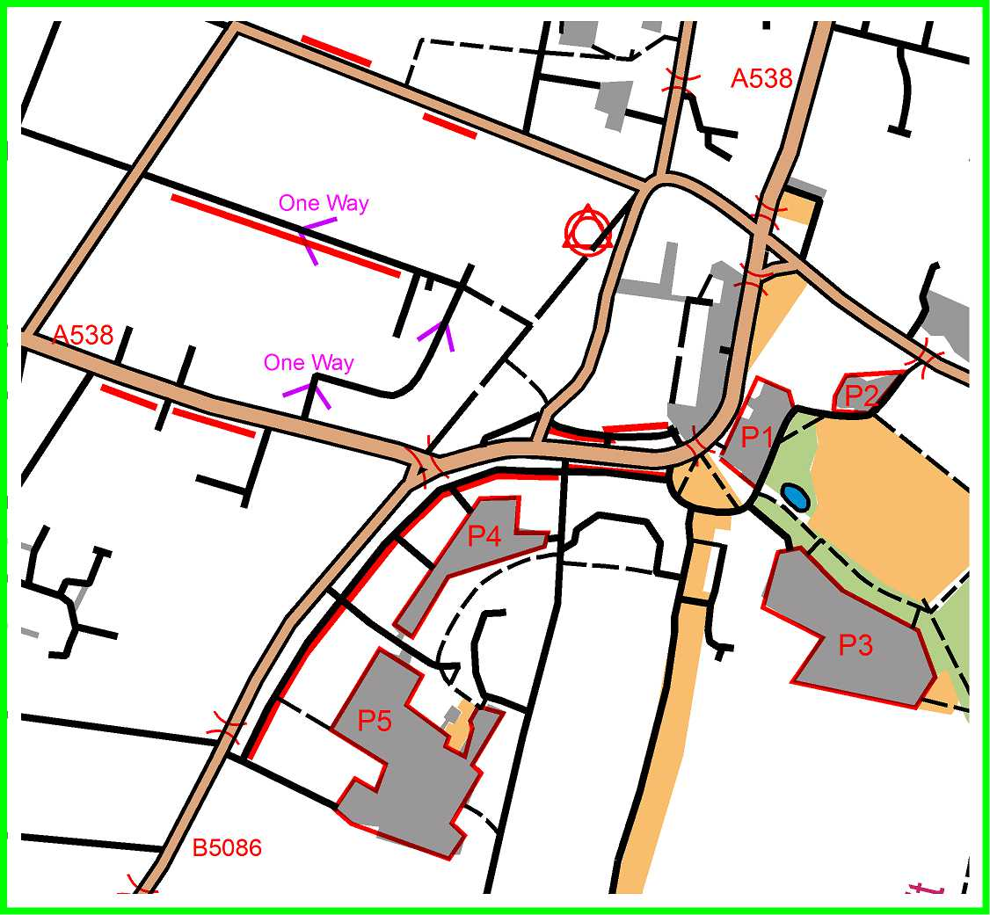Car parks P1-5 are pay-and-display car parks, free after 6pm.
Red lines show roadside parking bays, unrestricted after 6pm.
For preference use P1 or P4.
From P1, cross Alderley road at Pelican. Proceed N along Alderley Rd to traffic lights. Turn left into Swan Street and follow round to left, to the end of Grove Street (pedestrianised). The Old Dancer is 50m on the right.
From P4, cross using Pelican at junction of Alderley Rd and Water Lane, and proceed NE along Grove Street (pedestrianised). The Old Dancer is 200m on the left.
Registration will be upstairs in the Old Dancer, and the Start & Finish right outside.
Food :
The Old Dancer have offered a hot/cold buffet at £5 per head, including quiches, fries, sweet potato fries, bread, cold meats, cheeses etc (See the ‘Small Plates’ on their menu http://www.theolddancer.co.uk/menu.php )
You are welcome to order items from their regular menu, but as they only have a small kitchen, there may be a delay on serving these.
NUMBERS ARE REQUIRED FOR THE BUFFET BY FRIDAY 13th FEB AT 9PM

