Victoria Baths Sportacular

Frequently Asked Questions (FAQs)

What size table will I be given?
Stallholders will be given one 750 x 1800mm (6’ x 2’ 6”) table.

Can I have more than one table?
Yes

Will there be wall space available?
Wall space is limited and as Victoria Baths is a listed building the use of nails, screws or staples is strictly forbidden. Using Blu-tack or resting items against the walls is fine.
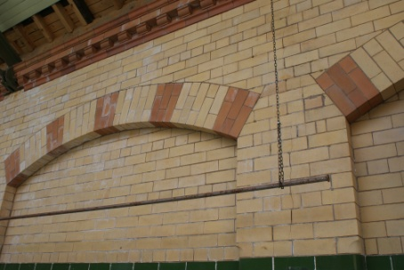
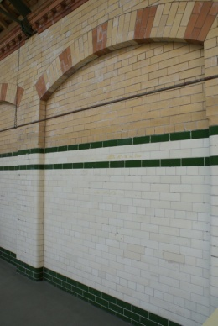
Hanging space is available behind some of the stalls.

e.g. downstairs, string can be hung between posts for display of a lighter items; upstairs, there are hanging rails above each table.

Will there be additional display space around my stall table?
We can allocate space to the side of tables. Please specify your requirements on the booking application form.

Can my stall be on the ground floor/upstairs balcony?
Please request this on your booking application form, and we will do our best to accommodate you, but cannot guarantee a particular location.

Will you provide chairs?
Yes 2 chairs per table. If you require more, please request on the booking application form.

Can I have a power supply?
Yes, if you request it on the booking application form.

Can I help publicise the event?
Yes please! We can send flyers either as hard copy or electronically, to use online e.g. via social media.

Customer Payment Facilities
Unfortunately Victoria Baths cannot provide a card machine for stallholders to use. There are 2 cash machines on Hathersage Road, just a short walk from the Baths.

What time will I be able to set up?
The building will be open to stallholders from 8.30am and we request that you finish setting up your stall by no later than 10.30am.

What are the opening hours?
The open day will be open to the public from 11am-4pm. Stallholders must not dismantle their stall or any displays until 4pm please.

Where can I get a cup of tea or coffee?
Hot and cold drinks will be available in the café from 11am. A full café service with hot food, served from approximately 12 noon is also available in the main café.

Victoria Baths Art & Craft Fair

Stallholder Terms & Conditions

Stallholders are advised to read the contents of these Terms and Conditions carefully before submitting a Booking Application Form

1. Allocation of Stall
The organisers reserve the right to refuse an application for stall space, without giving reasons.

2. Setup and dismantling
stallholders may set up 2.5 hours prior to the event opening (8.30am) and are responsible for carrying their own materials to and from the building. Please note there are no lifts in the building. Stallholders must not obstruct access to emergency vehicles during loading or unloading. Stallholders must not dismantle until 4pm and must vacate the premises by 5pm.

4. Insurance & Liability
The stallholder agrees and acknowledges that they are responsible for safeguarding their possessions, materials and property during an event.

5. Electrical Installation
A 13 amp electrical supply can be supplied to stalls. All electrical items should be safe and bear a current electrical safety certificate, provided by the stallholder at their own expense. The organisers reserve the right to remove any electrical equipment considered to be dangerous.

6. Damage to the Venue - Victoria Baths is a listed building
No nails, screws, bolts or other fixtures may be attached to any part of the Baths, including floors. Nor may any part of the Baths be damaged or disfigured in any way. Should any such damage or disfigurement occur, the stallholder responsible shall be directly liable for any repair charges incurred?

7. Advertising Matter
Stallholders may only distribute advertising or promotional material in the immediate vicinity of their own stand. Stallholders must agree to withdraw any advertising material at the Fair which the organisers may reasonably object to, for example on the grounds of legality, decency or honesty. Any audio-visual system that would in the opinion of the organisers cause annoyance or disturbance to others must also be stopped.

8 Fire Precautions
Inflammable decorations or fixtures shall not be placed or erected in the Baths. Fire points must be kept clear at all times and the stallholder must comply with any reasonable instructions given by organisers to avoid risk of fire.

Issue ref: April 2016 Victoria Baths

