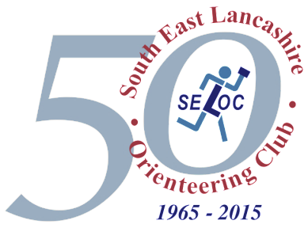
SOUTH EAST LANCASHIRE ORIENTEERING CLUB

Alkrington

Level C event including North West Heat for the
Yvette Baker Trophy

Sunday 2nd April 2017

Saturday 2nd May 2015

LOCATION: Alkrington, Middleton, North Manchester

TERRAIN: Mainly deciduous woodland with open fields, interspersed with lakes, ponds, rhododendrons, a distinct path network and bisected by a river and stream.

MAP: Blue, green, Light green on 1:10000, white, yellow, orange are printed on 1:7500

COURSES: White, Yellow, Orange, Light Green, Green, Blue, open to all.

TIMES: Registration: 10:00 – 12:00
Starts: 10:30 – 12:30
Courses close: 14:30

ENTRY: Entry via Fabian.
Juniors for Yvette Baker Trophy Qualifier should pre-enter only via Fabian.
Club Team information to organiser by online closing date (26/3/2017) please.
There will be entry on the day for individuals.

Seniors | £8.00 (£9 on the day)  for light green and above  £5 (£6 on the day)  for orange and below
Juniors | £5.00 (£6 on the day)
FEES:
SELOC helpers please contact organiser for helpers code.
SI card hire £1

DOGS: Dogs welcome but must be on lead.

SAFETY: Competitors take part at their own risk. The courses will be set in an area surrounded by a motorway, a main road and a housing estate. A river bisects the area and is only crossable at the marked crossing points. The motorway is out of bounds and access is prevented by a high fence. All courses will start on one side of the motorway and use the motorway underpass to get to the first control. The blue course will traverse the motorway on several occasions and is only crossable at the marked crossing points. Courses are planned so that competitors do not need to enter the housing estate or run along the main road. There is one main track in the east of the area used for vehicle access to a lone residence.

OFFICIALS: Organiser: Caroline Barcham (SELOC) e-mail: secretary@seloc.org.uk
Planner: Dean Thetford (SELOC)
Controller: Paul Turner (SELOC)

