Chapel-en-le-Frith NSL 1st February 2018

https://www.google.co.uk/maps/@53.3234136,-1.9157521,173m/data=!3m1!1e3?hl=en

Travel
B5470 from Macclesfield/Whaley Bridge
A6 to Whaley Bridge and approach Chapel from the east, i.e. along the A6 bypass, or come through Whaley and join the B5470 approaching Chapel from the west.
Note: you cannot turn right into Eccles Road from Cross Street as it is one way. To get to the parking in front of the pub you will need to turn left immediately after the Kings Arms
Note: if coming by train the station is ~1.5km from the pub

Parking

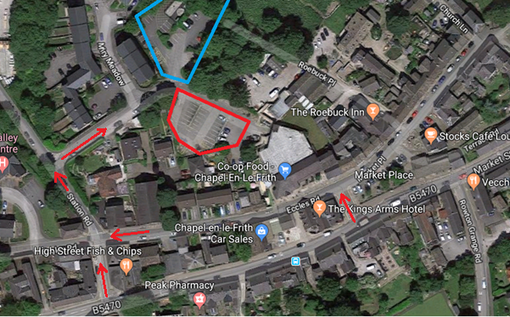
There is limited (20+) parking in the village ‘square’ outside the Roebuck, Stocks Cafe and along Market Place/Eccles Road.
There is free parking the Miry Meadow car park (blue polygon) off Station Road which is behind the Co-op
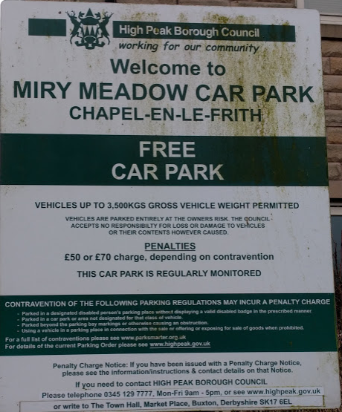
There is parking in the Co-op car park (red polygon) for Co-op customers (CHECK RESTRICTIONS ON THIS!)
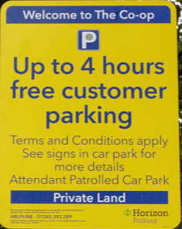
There is parking at Morrisons further down Market Street for Morrisons customers (CHECK RESTRICTIONS ON THIS!)
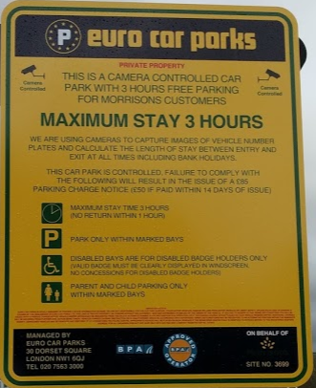

Venue
The Roebuck is a small pub so we may well fill it, please be patient as the pub has been very helpful in allowing the event to take place.

Courses
Chapel en le Frith is a smaller area than many used for NSL.
Test runs have shown that the optimum all controls route on the map is ~16.2km with ~144m of climb (with a maximum score of 2050 points). This will easily cater for 40 and 60minute runners.
However, this distance is borderline for some of our fitter and faster runners, so …….
for 75minute runners (only!)
there is an opportunity to exchange your map when you have been running for at least 60 minutes. The map exchange will take place at/near the start, and you must hand in your first map and answer sheet. There will also be a “control” (an SI box) which you MUST punch (dib!) Penalties (the same as those for late finishing) will be applied if you exchange early.
The second map covers only the most interesting part of the area, and will have 15 controls each of which is worth 20 points. Test runs have shown that the optimum all controls route on the second map is 4.25km with 30m of climb.
Note that the map exchange is NOT compulsory. We are confident that there is enough to keep most 75minute runners very busy on map 1.

