Walter’s Walk 5k Run /1M Fun Walk
2019 Sponsorship Packet
Creve Coeur Park, Tremayne Shelter
Sunday, September 22, 2019
7am Registration, Race at 9AM, Walk at 9:30AM
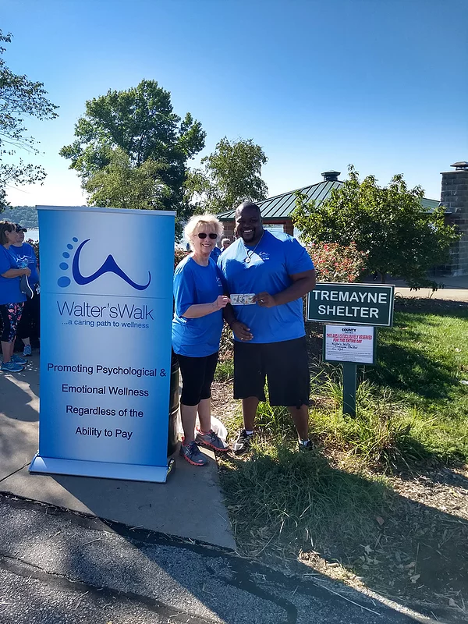
Walter's Walk Mission
Walter’s Walk is a purposeful 501 (c)(3) non-profit organization whose staff and sponsors are dedicated to providing mental-wellness counseling to those in need. Our qualified counselors focus on trauma, anxiety, and depression. We provide services to each and every individual who reaches out to us regardless of ability to pay. All of our counselors and professionals are committed to the wellness of the community by serving those in need, including First Responders, Veterans and their families

Walter’s Walk provides not only counseling, but also EMDR therapy, massage therapy, craniosacral therapy, yoga, spiritual direction and a variety of workshops and groups. This fundraiser provides an opportunity for more persons in the community to receive needed mental-wellness treatment. Our race last year provided services for more than 210 people. Since our doors opened in March 2010, we have provided services to more than 1,400 clients, equivalent to $1,400,00.00 if billed. Thanks to generous donors and successful fundraisers, we continue to provide these services at little or no cost.

We hope you will assist us in fulfilling our vision of turning away no one who seeks mental wellness services at Walter’s Walk. To become a sponsor, contact Dr. Jean Moretto at the following phone numbers and/or email addresses.

Race Coordinator: Please Visit our Homepage to learn more about us
Dr. Jean Moretto LPC, PhD www.walterswalk.com
Email: jeanmoretto@att.net 314-731-2433 Facebook www.facebook.com/walterswalk1
Will you become a sponsor?
BENEFITS
Demonstrate values and vision
Give back to the community
Employee team-building and motivation
Brand awareness and loyalty
Community relations

Sponsorship Levels
Platinum Sponsorship
Package
- Black & White Company Logo and/or name on Race Shirt
- Signage at race
- Recognition by Masters of Ceremony at start of Race
- Space for Booth and Signage at Race
- Four Complimentary Registrations
- Charitable Contribution: $1,000 – $2,500. Please make checks payable Walter’s Walk

Gold Sponsorship
Package
- Black & White Name Listed on Race Shirt
- Signage at Race
- Two Complimentary Registrations
- Charitable Contribution: $500 - $999. Please make checks payable Walter’s Walk

Silver Sponsorship
Package
- Black & White Name Listed on Race Shirt
- Signage at Race
- One Complimentary Registration
- Charitable Contribution: $250 - $499. Please make checks payable Walter’s Walk

Thank You
From the Walter’s Walk Team
At 737 Dunn Road, Hazelwood, MO 63042
