Brief Blurb
The American Bankers Association Foundation (ABA Foundation) launched the Safe Banking for Seniors campaign to connect communities with their local bankers to combat elder financial exploitation. Through the program, communities can request free banker-led presentations to educate seniors, their families, and caregivers on avoiding scams, preventing identity theft, and financial caregiving.
Organizations, coalitions, agencies, police departments, ministries and the like can request presentations using the ABA Foundation’s FinEdLink online portal. Visit www.aba.com/FinEdLink today, click the blue presentation request form to connect with a local bank, and help protect older Americans in your community.
Questions? Contact Sam Kunjukunju at the ABA Foundation.

Graphics:
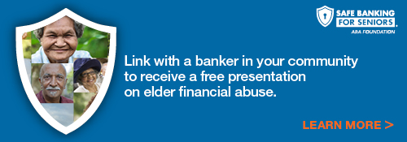
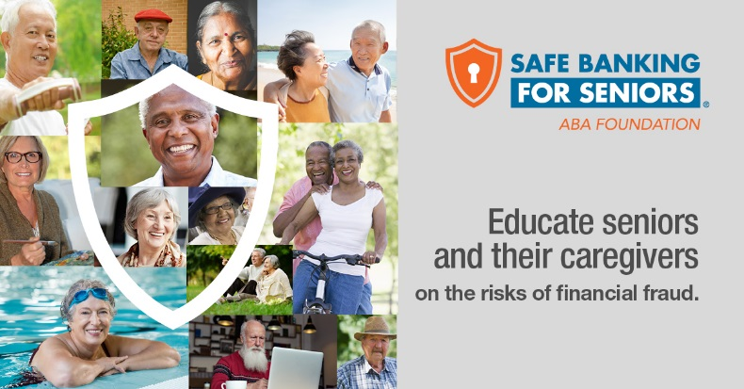

Please note that when using the graphics, please be sure to link them to: www.aba.com/FinEdLink

