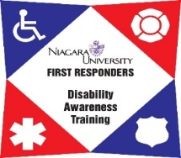

Firefighter/EMS Disability Awareness Train the Trainer
March 10th & 11th, 2020
Joplin Fire Department Training Center, Joplin, MO
The Niagara University First Responder Disability Awareness Training (NU FRDAT) program is pleased to announce a Firefighter/EMS Disability Awareness Train the Trainer session in Joplin, MO.

If you are a firefighter or EMS personnel who has an interest in educating your peers on how to properly respond to individuals with disabilities, we invite you to register for the upcoming training session.

Developed with input from firefighters and EMS personnel from Missouri, NY and FDNY. FRDAT both sensitizes and educates emergency responders on how to effectively identify, address, and respond to various disabilities they will encounter in their line of duty.

This program is developed strictly for firefighters and EMS personnel with the intent to TRAIN other firefighters and EMS in our disability awareness curriculum. This is NOT a training session for those who do not intend to train their peers. Once trained, you will have the responsibility of conducting the training and reporting your sessions to our office. You will receive EMS credit hours for attending.

This is a FREE training. All attendees must pre-register online and be approved by the Project Director in order to attend. We hope you consider participating in this crucial training and help us disseminate this curriculum.

Date: March 10th & 11th, 2020
Time: 8:30am-5:00pm
Place: Joplin Fire Department Training Center
5102 Swede Ln
Joplin, MO 64801
Lunch is not provided
REGISTER at http://frdat.niagara.edu/ or CLICK HERE

For more information, please contact: Host contact info:
Cary Newman, Program Manager Dustin Lunow
carynewman@niagara.edu EMS Training Chief
Phone: 716-286-8139 Joplin Fire Department
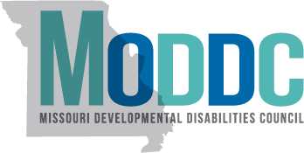
frdat.niagara.edu/ Phone: 417-624-0820 ext 1-308 .
This two-day training is funded by a grant through Missouri Developmental Disabilities Council

