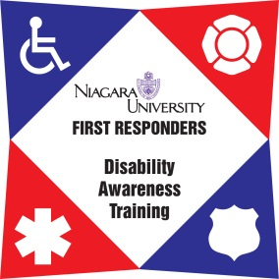
Law Enforcement Disability Awareness
Train the Trainer– Lee’s Summit Police Department Training Facility April 27th & 28th, 2020
8:00am-5:00pm both days

The First Responder Disability Awareness Training project at Niagara University is pleased to announce the Train the Trainer program for Law Enforcement personnel in the State of Missouri, to be held at the Lee’s Summit Police Department Training Facility.
If you are a first responder who has an interest in educating your peers on how to properly respond to individuals with disabilities, we invite you to register for one of the upcoming training sessions.

Developed with input from First responders from across Missouri and New York State, this training both sensitizes and educates law enforcement on how to effectively identify, address, and respond to various disabilities they will encounter in their line of duty.

This program is developed strictly for law enforcement personnel with the intent to TRAIN other law enforcement officers. This is NOT a training session for those who do not intend to train their peers. NU FR-DAT will track all attendees in this session relative to the department or agency they belong to and record when they train law enforcement personnel. This is a FREE training.

DATE: April 27 & 28, 2020
WHEN: 8:00am-5:00pm both days (Both Days MUST be attended to receive credit)
WHERE: Lee’s Summit Police Department
Training Facility (Enter at the NE corner of the building)
10 NE Tudor Road, Lee’s Summit, MO 64086
Phone: 816.969.1735
For registration please visit https://frdat.niagara.edu/or click here

Local Lodging Options:
1) Holiday Inn Express - 1201 NW Innovation Parkway , Lee's Summit, MO 64086,
Phone: 855-657-1844
2) Hampton Inn - 1751 NE Douglas St, Lee's Summit, MO 64086
Phone: (816) 347-8600

For more information, please contact: Host Contact:
Cary Newman, Program Manager PO Dan Wood
carynewman@niagara.edu Training Coordinator
Phone: (716) 286-8139 Phone: 816-969-1735
http://frdat.niagara.edu/
www.facebook.com/nufrdat

This two-day training is funded by a grant through the Missouri Developmental Disabilities Council.

