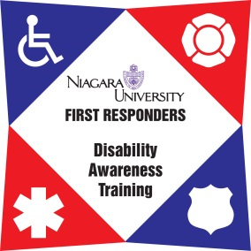

9-1-1 Telecommunicator Disability Awareness
Train the Trainer– Lee’s Summit Police Department Training Facility
April 29th & 30th, 2020
8:30am-4:30pm both days

The First Responder Disability Awareness Training project at Niagara University is pleased to announce a Train the Trainer program for 9-1-1 Telecommunicators personnel in the State of Missouri, to be held at the Lee’s Summit Police Department Training Facility.
Niagara University’s First Responder Disability Awareness Training (NU FR-DAT) helps to both sensitize and educate on how to effectively identify, address, and respond to various disabilities that 911 professionals may encounter in the line of duty. The National Emergency Numbers Association (NENA) recognizes this program as the only comprehensive disability awareness training program for emergency telecommunicators.
This program is developed strictly for 9-1-1 personnel with the intent to TRAIN other telecommunicators. This is NOT a training session for those who do not intend to train their peers. Once trained, trainers will conduct the training and coordinate with Niagara University for ongoing reporting and certification for attendees.
Training materials and attendance are FREE. Out of state Attendees are subject to a $350.00 registration fee. We hope you consider participating in this important training.

DATE: April 29th & 30th, 2020
WHEN: 8:30am-4:30pm both days
WHERE: Lee’s Summit Police Department
Training Facility (Enter at the NE corner of the building)
10 NE Tudor Road, Lee’s Summit, MO 64086
Phone: 816-969-1735

For registration please visit https://frdat.niagara.edu/or click here
Lunch will not be provided. Numerous lunch opportunities are located within a few miles of the Academy.

For more information, please contact: Host Contact:
Cary Newman, Program Manager Officer Dan Wood-Training Coordinator
Phone: (716) 286-8139 Phone: 816-969-1735
carynewman@niagara.edu Email: Daniel.Wood@cityofls.net
http://frdat.niagara.edu/
www.facebook.com/nufrdat

This two-day training is funded by a grant through the Missouri Developmental Disabilities Council.

