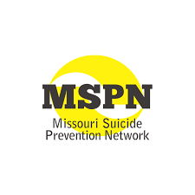
Missouri Suicide Prevention Network
Monthly Data Report
October 14, 2020
Suicides

All mortality data were obtained from the Missouri Department of Health and Senior Services. These data are provisional and subject to change. Data are based on place of decedent residence, not location of suicide.

National Suicide Prevention Lifeline Calls

Crisis Text Line

2020 Campaign
September-November
2020 Campaign
May-June
2019 Campaign
June-July

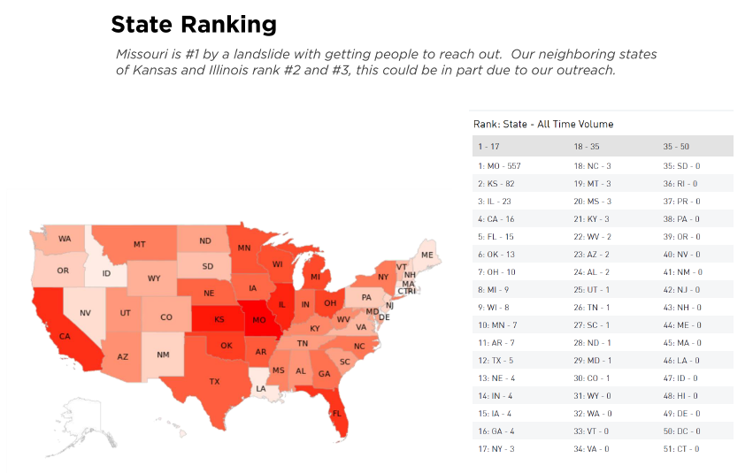
Emergency Department Visits
December 2019 – July 2020

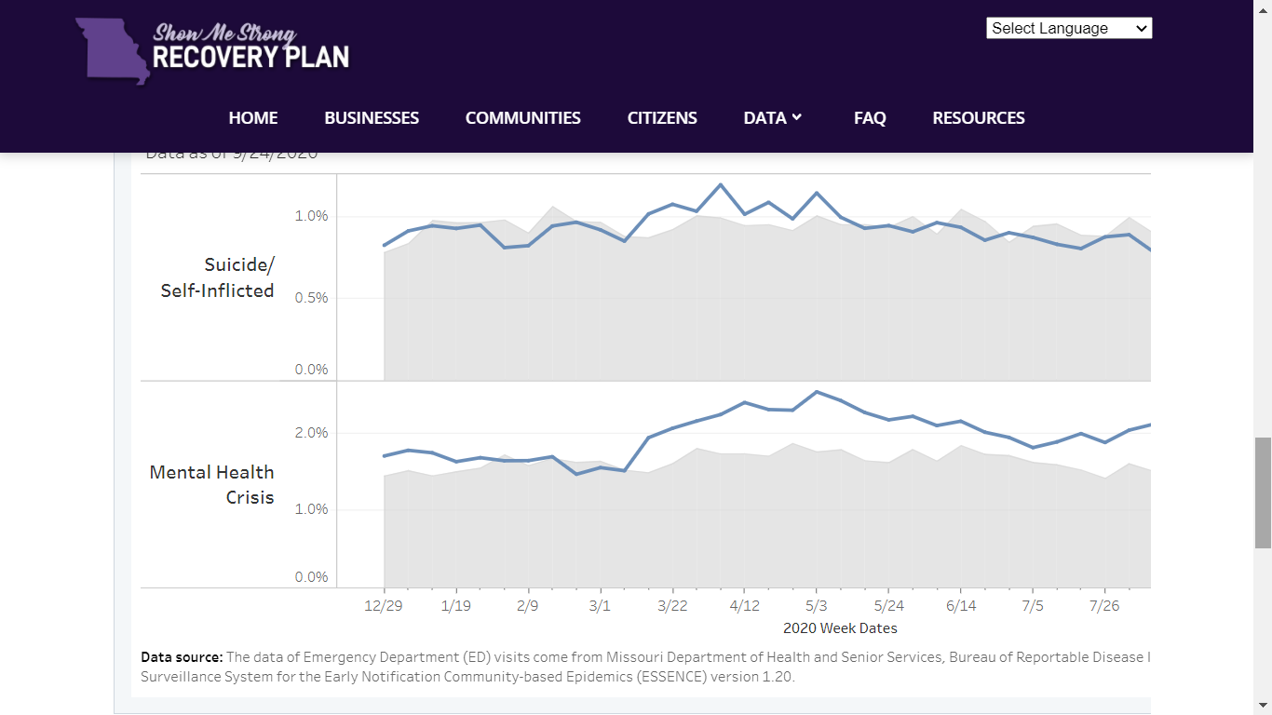

Results from Substance Use and Mental Health in
Missouri during COVID-10 Facebook Survey
(n=1,999)

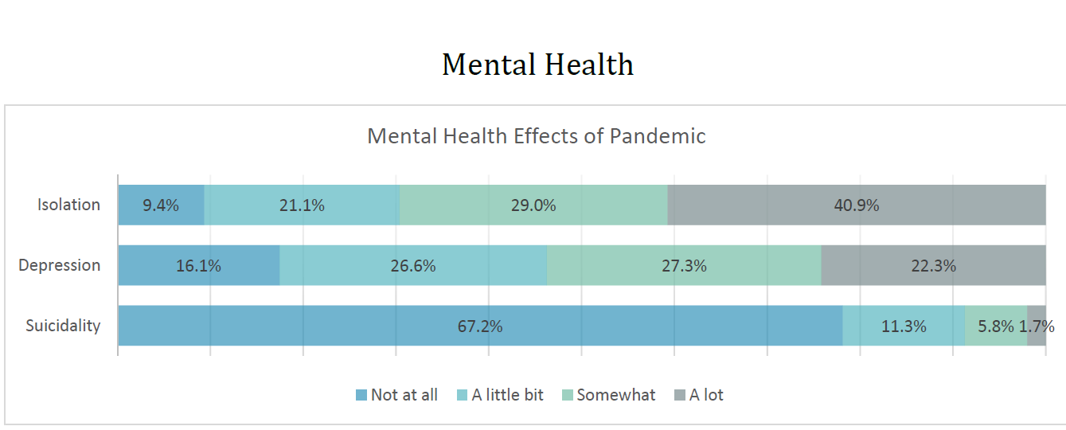

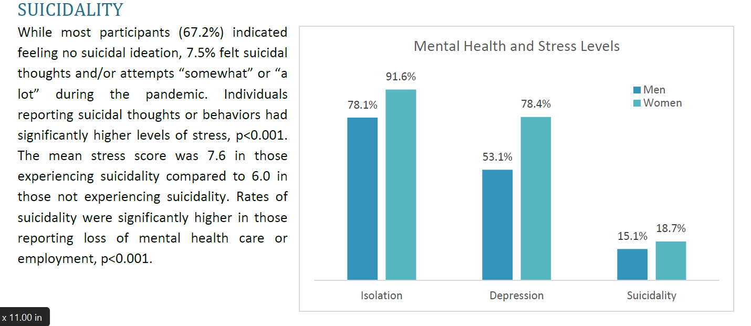
References
This data brief was prepared by researchers at the Missouri Institute of Mental Health, University of Missouri – St. Louis, for the Missouri Suicide Prevention Network (mspn.org). Mortality and emergency department data were provided by the Missouri Department of Health and Senior Services. Data on Missouri Lifeline calls were provided by the National Suicide Prevention Lifeline (https://suicidepreventionlifeline.org/) and Crisis Text Line data were provided by Crisis Text Line (crisistextline.org). Data are also available to the public on the Missouri Show Me Strong website (https://showmestrong.mo.gov). The Substance Use and Mental Health in Missouri during COVID-10 Facebook Survey Report was produced by the Missouri Institute of Mental Health (MIMH) for the Missouri Department of Mental Health. For additional questions regarding these data, please contact Liz Sale, PhD, at liz.sale@mimh.edu.

